**Report of A Three Day Virtual workshop on Research Methodology and Data Analysis Workshop (RMDA-2021).**

Department of Chemical Engineering, RGUKT, Basar Organized A Three Day Virtual workshop on Research Methodology and Data Analysis (RMDA-2021) from 24th -26th , April,2021. **Mr. Haribabu P** Asst.Professor, Head of the Department, was the Chairperson of the workshop. **Mrs.Srujana D** Asst.Professor was the Convener and **Mr.Ramaraju B** and **Mr.Vinay kumar S** Asst.Professor, Department of Chemical Engineering were the Coordinators of the workshop.

The core objective of the workshop was to equip the participants with set of skills and potentiality to undertake the research very effectively in any discipline and to turn completed research into publishable material of high quality in the form of articles, journals and books.

This workshop was designed to offer the practical guidelines and direct the researchers through all the stages of research from identifying a research problem to the submission of a dissertation, report writing and research article. The course intends to deal with variety of quantitative and qualitative research methods used in journey of research. It also gives exposure to data analysis with the help of software packages.

The workshop consists of both theory and practical. By the end of the programme they were expected to develop conceptual clarity and practical knowledge to undertake quality research and writing good research papers field-reports and project proposals etc. The workshop commenced, after the registration of participants online.

Number of resource persons were invited to deliver insightful information on various topics of contents of the workshop. The resource persons were the one with expertise in the respective fields and associated with some of the institutions of eminence. The list with detailed information about resource persons was shared as an enclosure for approval form the university for official communication. A total of 180 participants from the various fields of engineering bachelors and research scholars were the part of this workshop. All the sessions were systematically arranged keeping in mind the need of the participants.

The sessions were as follows:

**Day 1: 24th April, 2021.**

Mrs.Srujana D Workshop Convener, heartily welcomed all the guests, participants, faculty members and students and gave an introductory speech about the University and Department of Chemical Engineering. She welcomed Patron Prof.Y.Rajeshwar Rao, Administrative Officer, RGUKT, Basar to address the participants and workshop RMDA-2021. Prof.Y.Rajeshwar Rao, Administrative Officer, applauded the department’s effort in organizing such a meaningful event, he also encouraged the participants to take interest in the workshop and make use of it in the journey of research.

Later on Mrs. Srujana D Workshop Convener highlighted the overview of the workshop with core aims, objectives and outcomes. She has explained about the workshop to participants and assured them of a learning experience provided in this workshop through both theory and practical sessions surely equip the researchers to carry out successful research works and overcome potential challenges. She also introduced Dr.ISR Shastri, the resource person of session I: Introduction to the research methodology and methods. Dr.ISR Shastri, Head of the Department of Metallurgical and Materials Engineering, RGUKT,Basar.

**Session I(Slot-I) : Introduction to the research methodology and methods** was taken byDr.ISR Shastri. He started session with the definition of research by giving daily life examples. He highlighted types of research on the basis of various parameters, importance and its characteristics. He also opened an insight about importance and procedure of conducting Quality Doctoral Research in specific to Education. He explained the importance of two key concepts such as ‘research’, and ‘methodology’ to enable participants to understand the basics of any research in any field of education. It was pointed that research is a way of thinking. Dr.ISR Shastri, highlighted different types of Researches –

Quantitative, Qualitative and Mixed Method.

**Session I(Slot-II): Data analysis various statistical tools to be used in data analysis** was taken by

Prof. J.Hayavadana, Professor & Head, Department of Textile Technology, University College of Technology, Osmania University, HYD. Sir began his session with **Statistics** which is the discipline that concerns the collection, organization, analysis, interpretation, and presentation of data.

And he highlighted main statistical methods are used in [data analysis](https://en.wikipedia.org/wiki/Data_analysis) like [descriptive statistics](https://en.wikipedia.org/wiki/Descriptive_statistics), which summarize data from a sample using the [mean](https://en.wikipedia.org/wiki/Mean) or [standard deviation](https://en.wikipedia.org/wiki/Standard_deviation), and [inferential statistics](https://en.wikipedia.org/wiki/Statistical_inference). He explained two sets of properties of a distribution such as sample or population distributions under Descriptive statistics. And also gave insightful information on various statistical tools which are plays key role in the analysis of results. The session was ended with open question answer talk.

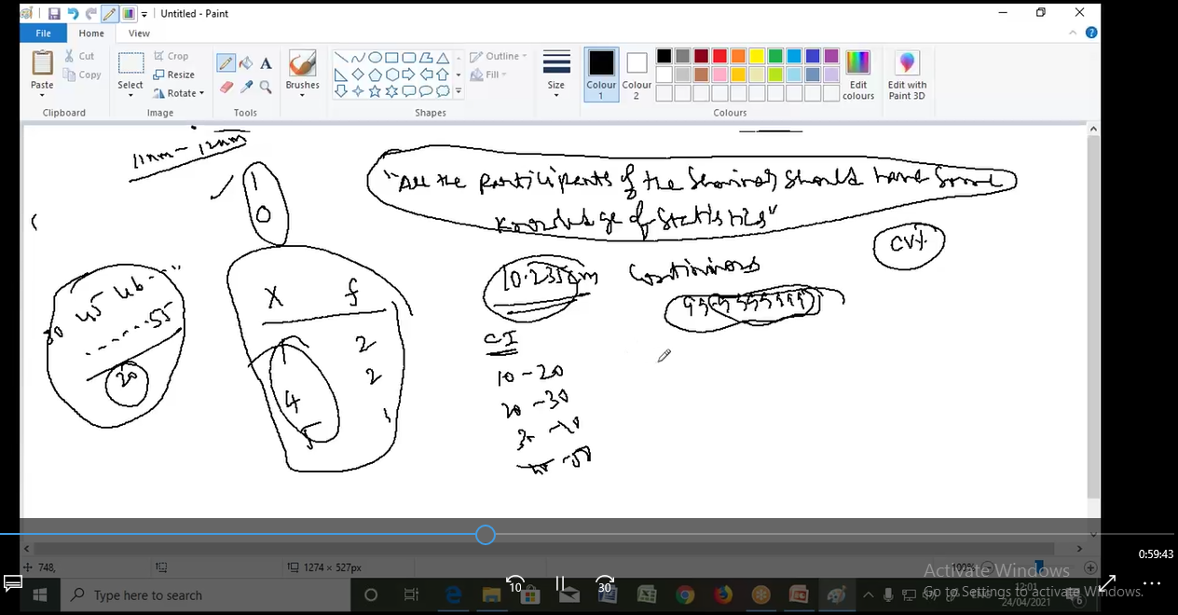

**Session II(Slot-I): Ethics in Research:** was taken by Dr. G.Devaraju, Associate Dean of Academics, Humanities and sciences, Assistant professor, Department of Physics,RGUKT, Basar. Sir started with an example of importance of Ethics in every moment of daily life. Then he deliberated his views on ethics and morality in research and integrity towards guide, towards the institution which plays major role in workplace. He also detailed about conduct and misconduct of research followed by its consequences. The session was ended with quiz type questionnaire to the participants.

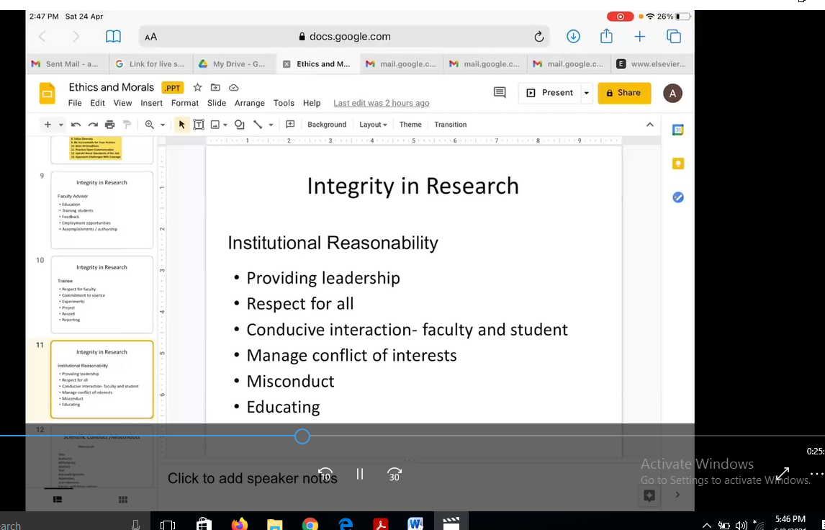

**Session II(Slot-II): Hands on training on Probability of Statistics to Researchers was** taken by Mrs.Srujana D, Assistant Professor, Department of Chemical engineering, RGUKT, Basar.

She started the session with the example of probability then moved on to the definition and application of it in various fields. She explained the terminology and types of events of probability with daily life examples. She demonstrated various probability distributions followed by hands on training on probability distribution using functions in MS-EXCEL.

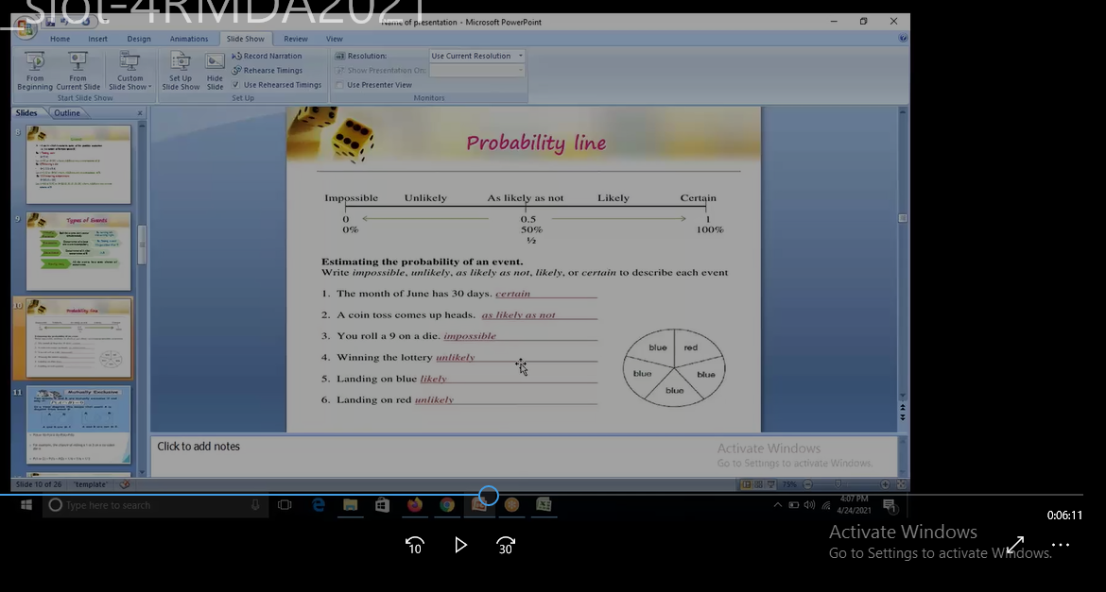

**Day 2: 25th April, 2021**

**Session I(Slot-I): Overview on Research Process** was taken by Dr. Ajay Kumar R, Assistant Professor, Department Of Metallurgical and Materials Engineering, RGUKT,Basar. He began the session with definition of research process and perspective of research in terms of UG, PG and Ph.D. students. He discussed various steps involved in Research Process. And detailed how to define a research problem, tips for literature survey and other constraints involved research process. He also highlighted the features of research proposal i.e. it shows that the proposed study has considered the available knowledge about it, viability and relevance of research is justifies; strengths and limitations of the approach are stated. And Session ended with open question and answer talk.



**Session I(Slot-II): Report Writing** was taken by Mr. Vinay Kumar S, Assistant Professor, Department of Chemical engineering, RGUKT, Basar. He started his session with the meaning of research report which means a condensed form or a brief description of the research work done by the researcher. He said that research report should be concise, clear, honest, complete and accurate. He also discussed the structure of research report and the format of a research report. He also explained the chapter wise writing of research thesis and the various elements of each chapter. He also pointed out the rules of typing, difficulties in writing a report and features of a good report.

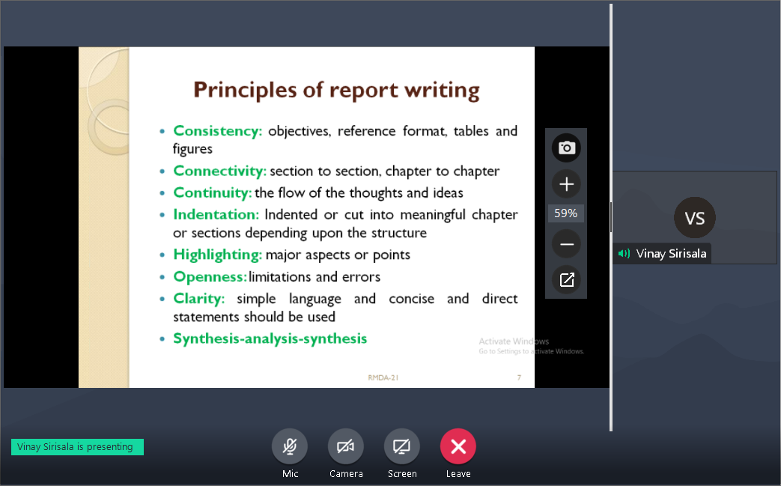

**Session II(Slot-I): Research Methodology and data Analytics: Digital Twin** was taken by Mr.A.RaviKiran, senior Process Engineer, Grace Davision Chemicals India Pvt,Ltd, Chennai. Sir began his session with Introduction to Data Analytics tools and various elements involved with it. Then he elaborated Digital Twin and its importance in various sectors like, Engineering, Operations and information Technologies. He gave complete insight of various software like Rprogramming, matlab, aspen and chemcad etc. He explored application of Digital twin in steel manufacturing process. He interacted with the students by sharing the opportunities of data Analysts in various fields. He ended the session with clarifying the queries of the participants.

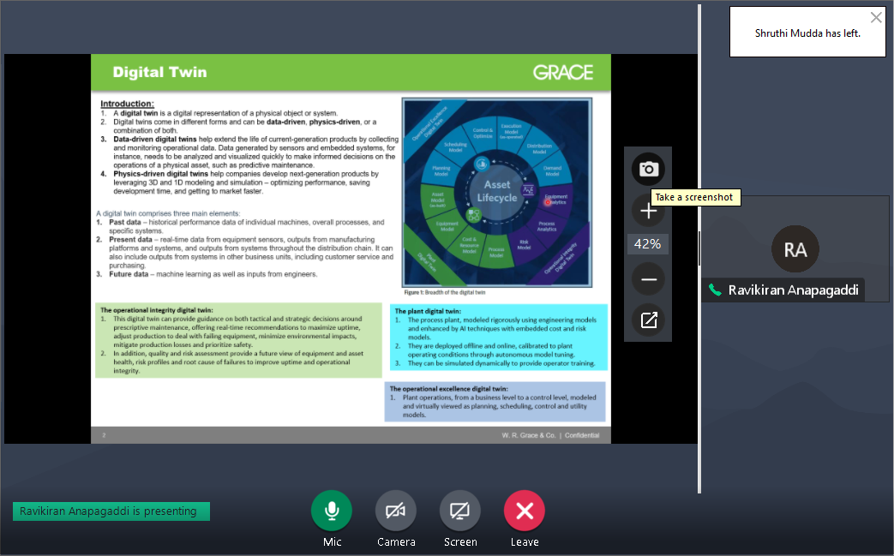

**Session II (Slot-II): Statistical Techniques, Heuristic Approach, Correlation and Regression** was taken by Mrs.Haritha Banothu, Assistant Professor, Department of Chemical engineering, RGUKT, Basar. She began her session with various statistical Techniques involved and their applications. She explained very adequately about Heuristic Approach Technique by using a case study example. She briefed correlation, types of Correlation and variables involved in it by solving numericals in EXCEL. She also explained Regression analysis and the difference between Correlation and Regression by analyzing the existed data. The session was ended with the comparing the answers between the speaker and Participants.

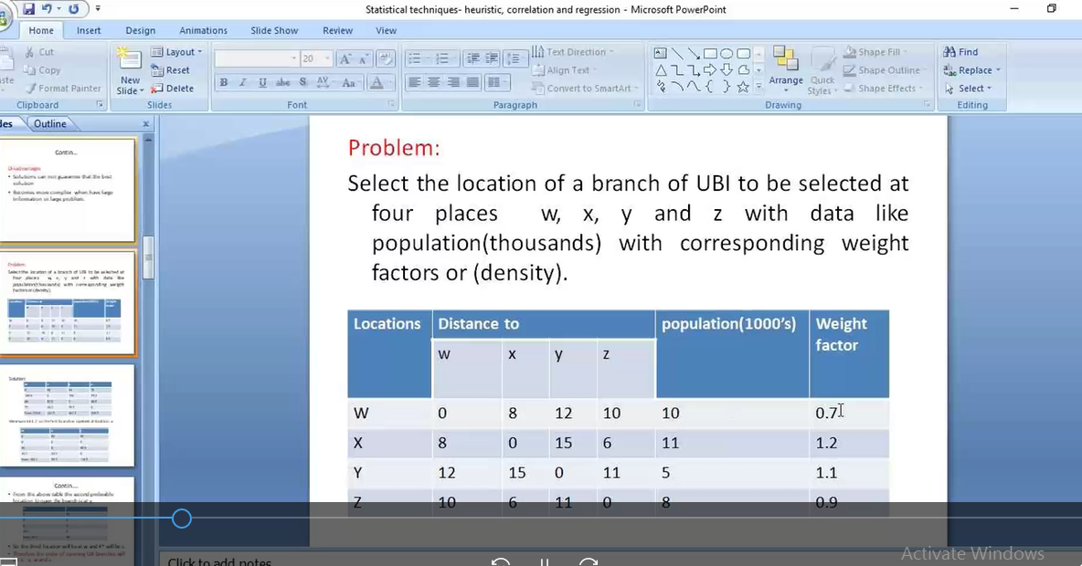

**Day 3: 26th April, 2021**

**Session I(Slot-I&II):** **Research Design, Hypothesis formulation**, **T-test, ANOVA analysis, Regression Analysis** was taken by Prof.Shashank Bansal, Assistant Professor, Department of Management Studies, ISM, Dhanbad. The entire session was filled with simple and beautiful examples which were easily understandable by the participants. He began with the meaning of hypothesis which means an intelligent guess or prediction that gives a direction to the researcher to answer his research question. She also talked about the contribution of hypothesis in the research study i.e. it gives clarity to the research problem, describes explains and predicts the expected results or outcomes, indicates the types of research, describe research design, identifies the population of the study, facilitates data collection, data analysis and data interpretation. He also explained types of hypothesis – Alternative hypothesis, null hypothesis. He highlighted t-test, z-test, ANOVA, one way ANOVA, two way ANOVA. He ended session with clarifying the doubts from participants.

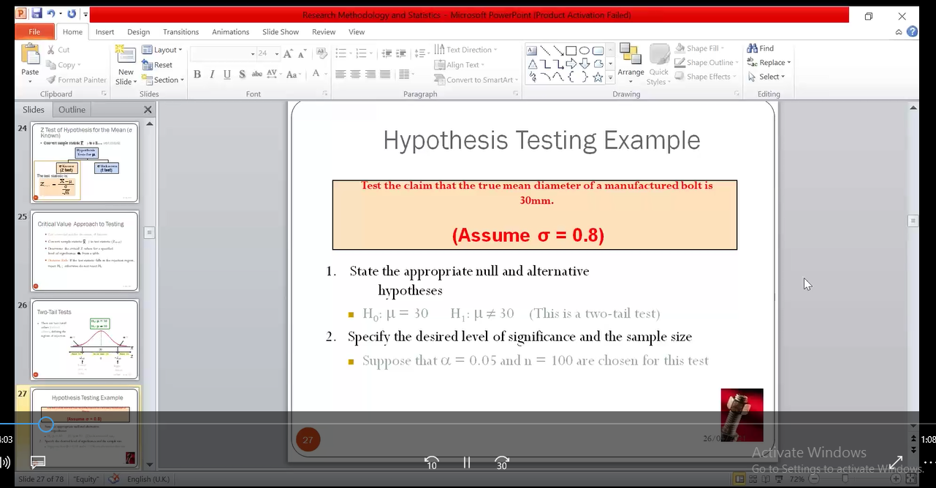

**Session II(Slot-I): Hands on experience on ANOVA ( one-way and two way ANOVA )** was taken by Mr. Srikanth K Assistant Professor, Department of Chemical engineering, RGUKT, Basar. Session-II was continuation of session-I. Sir started his session with explaining the importance of ANOVA analysis in data analysis. He explored various examples on ANOVA and techniques involving to select level of significance. He also demonstrated on analysing the data using ANOVA by hand calculations and using MS- EXCEL function as well. Students were actively participated in calculation part of the solution. The session ended with complete two way interaction between the speaker and the participants.

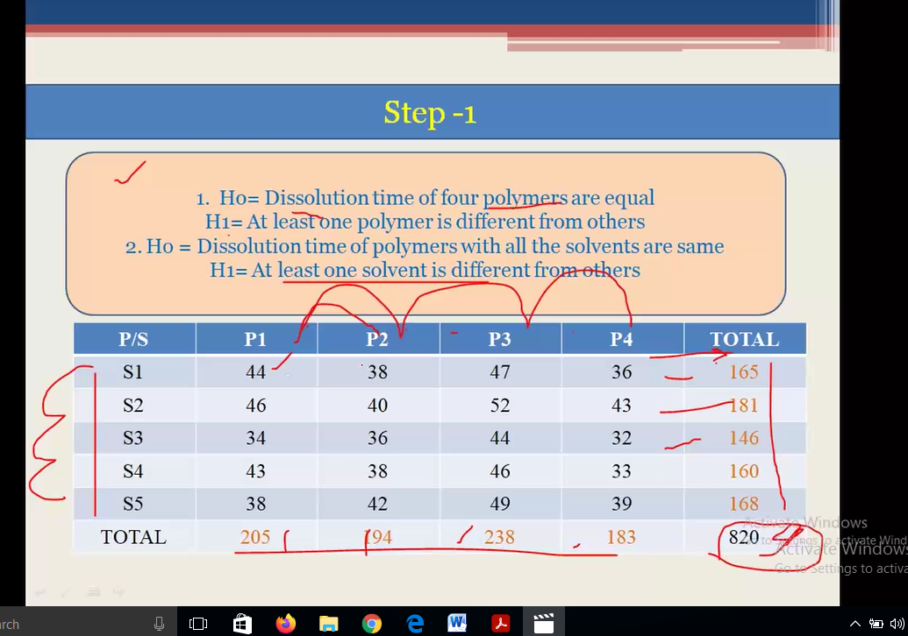

**Session II(Slot-II):** **Research Design:Factorial Experimental Design,Replication and Randomization, Blocking** was taken by Mr. Haribabu P, Assistant Professor, Head of the Department of Chemical engineering, RGUKT, Basar. He began the session with the term Research design and purpose of research design by considering a simple example. He also briefed the history involving with the design and types of research designs. Then he focused on Experimental design including types, basic principles (replication, randomization) involving with it, merits and demerits. He demonstrated the steps involving to solve design problems (latin square design and factorial design) by considering existed data examples. He drawn attention of the participants by solving numericals. And speaker ended the session by providing some more examples to solve by the participants on their own.

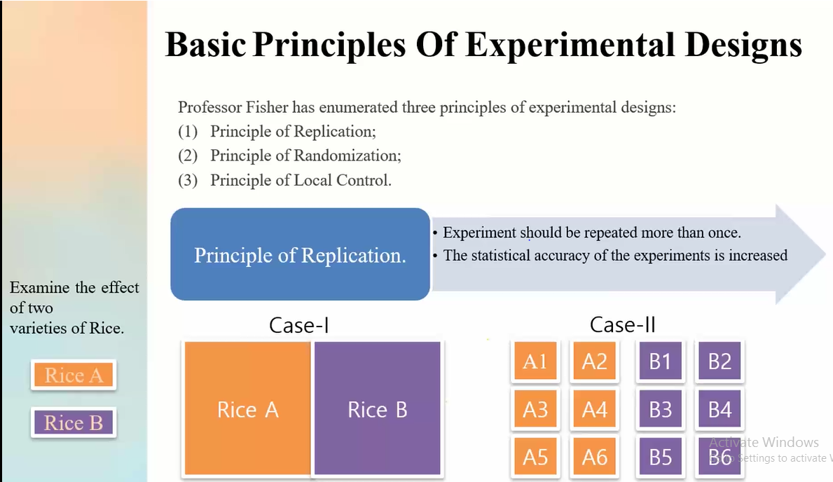

Finally, the workshop was concluded with a vote of thanks Mrs. Srujana D, Convener of the workshop proposed Mr.Haribabu P, Head of the Department of Chemical Engineering to deliver vote of thanks.

Mr.Haribabu P appreciated the convener, coordinators, faculty members and student volunteers for their restless efforts to make the event to be success. As a whole with the extended support of the management, head of the department and faculties made the event phenomenal success.

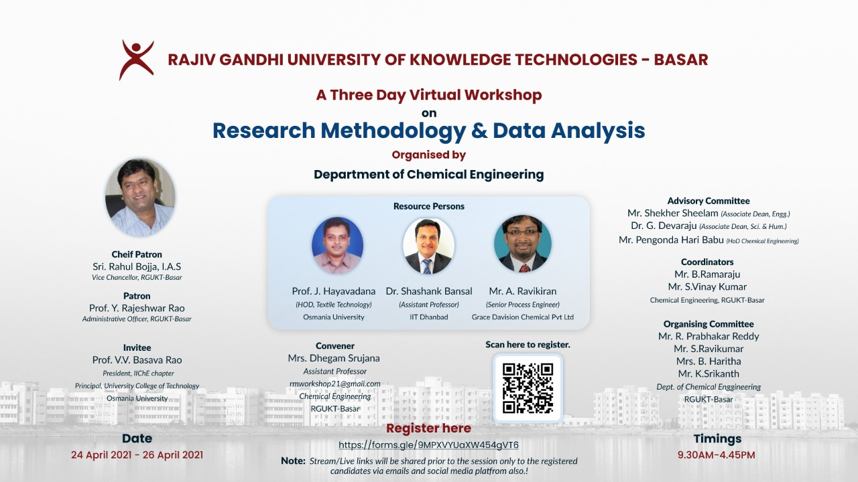

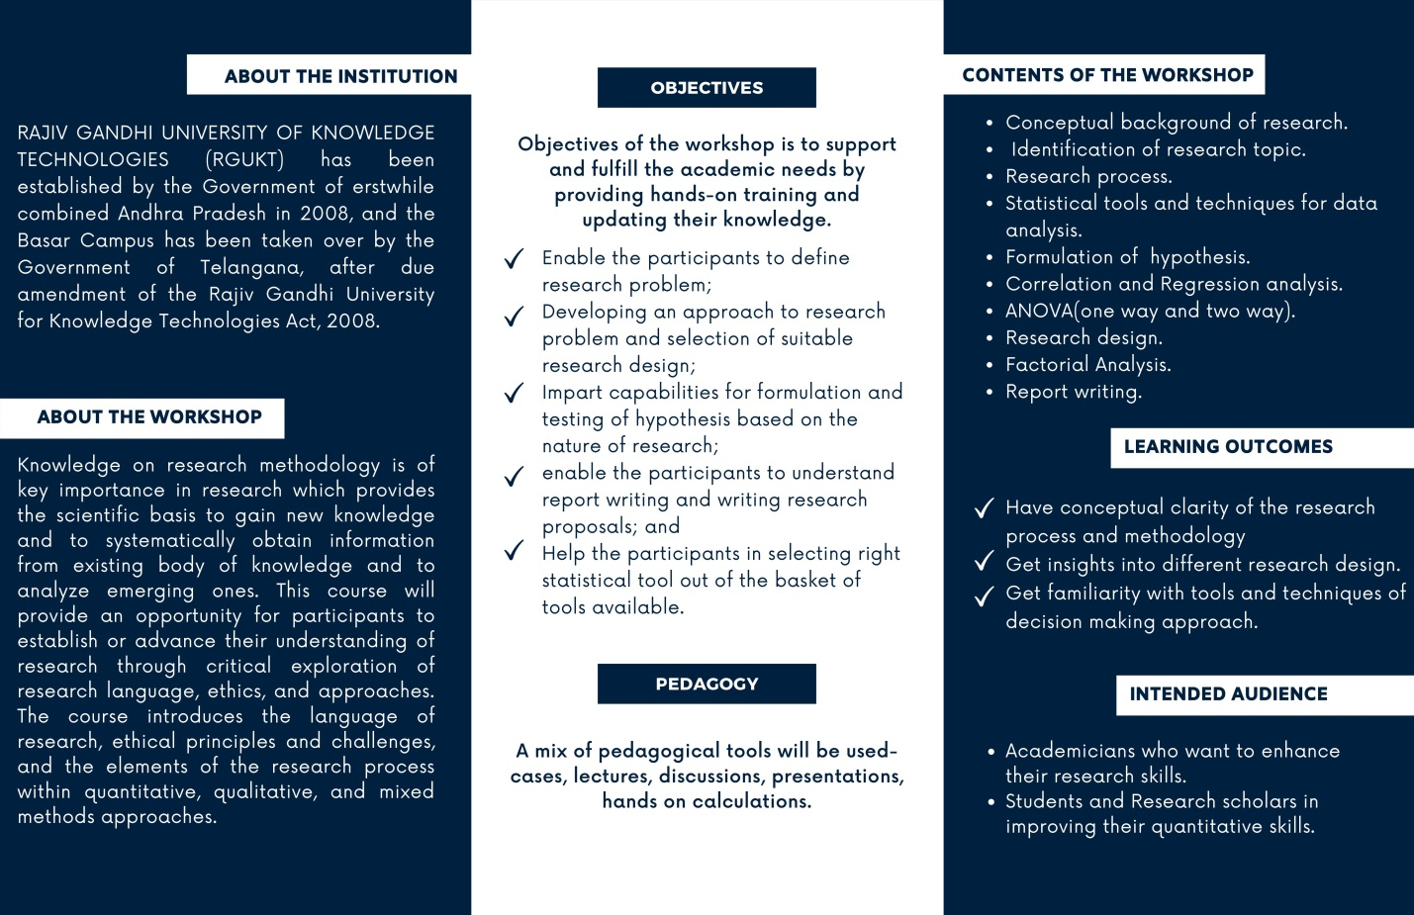

**A THREE DAY VIRTUAL WORKSHOP**

ON

**RESEARCH METHODOLOGY AND DATA ANALYSIS** (24th -26th April, 2021)

Organized By

DEPARTMENT OF CHEMICAL ENGINEERING



RAGIV GANDHI UNIVERSITY OF KNOWLEDGE TECHNOLOGIES BASAR (T.S.)

**About the Institution:**

RAJIV GANDHI UNIVERSITY OF KNOWLEDGE TECHNOLOGIES(RGUKT) has been established by the Government of erstwhile combined Andhra Pradesh in 2008, and the Basar campus has been taken over by the Government of Telangana, after due amendment of the Rajiv Gandhi University for Knowledge Technologies Act, 2008.

**About the Workshop:**

Knowledge on research methodology is of key importance in research which provides the scientific basis to gain new knowledge and to systematically obtain information from existing body of knowledge and to analyze emerging ones. This course will provide an opportunity for participants to establish or advance their understanding of research through critical exploration of research language, ethics, and approaches. The course introduces the language of research, ethical principles and challenges, and the elements of the research process within quantitative, qualitative, and mixed methods approaches.

**Objective of Workshop:**

Objectives of the workshop is to support and fulfill the academic needs by providing hands-on training and updating their knowledge with the methods to

* enable the participants to define research problem.
* developing an approach to research problem and selection of suitable research design.
* impart capabilities for formulation and testing of hypothesis based on the nature of research.
* enable the participants to understand report writing and writing research proposals.
* Help the participants in selecting right statistical tool out of the basket of tools available.

**Contents of the workshop :**

* Conceptual background of research.
* Identification of research topic.
* Research process.
* Statistical tools and techniques for data analysis.
* Formulation of hypothesis.
* Correlation and Regression analysis.
* ANOVA(one way and two way).
* Research design.
* Factorial Analysis.
* Report writing.

**Learning outcomes:**

At the end of the course the participants should be able to:

* Have conceptual clarity of the research process and methodology
* Get insights into different research design.
* Get familiarity with tools and techniques of decision making approach.

**Who Should Attend?**

This workshop should be helpful to-

* Academicians who want to enhance their research skills.
* Students and Research scholars in improving their quantitative skills.

**Pedagogy:**

* A mix of pedagogical tools will be used- cases, live streaming lectures, discussions, presentations and hands on calculations.

**Requirements for the course:**

Personal laptops/computers with good internet connectivity.

**Who can Apply??:**

* PhD research scholars, graduate and Post graduate students of any university in any branch are eligible to apply.

**Registration and payment details:**

* Registration fee: Rs.50/- for each participant.
* Fee to be paid at SBI with A/C No:62307233017 (D. Srujana) IFSC code: SBIN0014154
* Also to be paid through **G-Pay** or **Phonepe** at 7893088922
* Registration fee once paid will not be refunded in any case.
* E- Certificates will be provided to all the participants.

**Registration link:**

Interested candidates may submit their duly filled registration form along with Payment Transaction ID by clicking on

[**https://forms.gle/9MPXVYUaXW454gVT6**](https://forms.gle/9MPXVYUaXW454gVT6)

**Note:**

* Stream/Live links will be shared prior to the session only to the registered candidates via emails and social media platform group.

**Time and Venue:**

Date: 24th-26th April 2021 Time: 9.30am-4.45pm

Department of Chemical Engineering, Rajiv Gandhi University Of Knowledge Technologies, BASAR.

**Important dates:**

Last date of receipt of registration form: 20th April 2021. Workshop Dates: 24th-26th April, 2021

**Chief patron: Patron:**

Shri. Rahul Bojja, I.A.S Prof. Y.Rajeshwar Rao

Vice Chancellor, RGUKT- Basar. Administrative Officer, RGUKT- Basar.

**Invitees:**



Prof. Basava Rao, President, IIChE, Principal, OUCT, Osamania University

**Details of Resource Persons**

1. Prof. J.Hayavadana Professor & Head, Department of Textile Technology University College of Technology, Osmania University, HYD.
2. Dr. Shashank Bansal Assistant professor, Department of Management Studies Indian Institute of Technology (ISM), Dhanbad.
3. Mr. A. Ravikiran

M. Tech (IIT Madras), Senior Process Engineer, Grace Davision Chemical, India Pvt Ltd, Chennai.

**Advisory committee:**

Mr. Shekar Sheelam (Associate Dean of Engineering)

Dr. G. Devaraju (Associate Dean of Sciences and Humanities).

Mr. P.Haribabu; Asst.Professor, Head of the Department (CHE), RGUKT- Basar

**Convener:**

Mrs. D. Srujana; Asst. Professor, Dept of Chemical Engineering

**Ph.No**-7893088922,9441586624 **Mail**:rmworkshop21@gmail.com,srujana.dhegam@gmail.com & RTCH160315@rgukt.ac.in

**Co-Ordinators**:

Mr. B.Ramaraju; Asst.Professor, Ph.No-9493232260 Mr. S.Vinay kumar; Asst.Professor Ph.No-9441202536 **Organizing Committee:**

Mr. Prabhakar Reddy,

Mr. Ravi Kumar Saga,

Mrs. Haritha B,

Mr. Srikanth K

**Department of Chemical Engineering, RGUKT- Basar**

Three days Online Workshop on Research Methodology and Data Analysis

(24th-26th, April, 2021)

**Programme Schedule**

|  |  |  |
| --- | --- | --- |
| **Day 1-24th April 2021** | | |
| **Session** | **Themes** | **Speaker** |
| **9.30-9:40** | Inaugural session |  |
| **9:40-9:45** | Address by Patron. RGUKT Basar | Prof. Y.Rajeshwar Rao |
| **9:45-9:55** | Introduction about the Workshop | Mrs. Srujana D |
| **10:00-11:15** | Introduction to the research methodology and methods | Dr.ISR Shastri  HoD, Department of Metallurgical and Materials Engg |
| Break | | |
| **11:30-12:45** | Data analysis various statistical tools to be used in data analysis | Prof. J.Hayavadana  Professor& HoD, Textile Technology, UCT(OU). |
| Lunch break | | |
| **14:00-15:15** | Ethics in Research | Dr. G. Devaraju  Associate Dean, Humanities &Sciences, Physics |
| Break | | |
| **15:30-16:45** | Hands on Training on Probability of Statistics to Researchers | Mrs. Srujana D  Assistant professor Department of Chemical Engg |
| **Day 2-25th April 2021** | | |
| **10.00-11:15** | Overview on Research Process | Dr. R.Ajay kumar  Assistant professor  Department of Metallurgical and Materials Engg. |
| Break | | |
| **11:30-12:45** | **Report Writing:**  Publishing, Conf. Proceeding, Magazine , Journal, Transactions, Book Chapter and Book | Mr. Vinay kumar S  Assistant professor Department of Chemical Engg |
| Lunch break | | |
| 1. **–15:15** | Data Analytics with a case study | Mr. A. Ravikiran  Senior Process Engineer  Grace Davison Chemicals India Pvt, Ltd |
| Break | | |
| **15:30- 16:45** | Heutistic and Simulation modeling | Mrs. Haritha B  Assistant professor Department of Chemical Engg |
| **Day 3-26th April 2021** | | |
| **9:30- 11:00** | Research Design, Hypothesis formulation | Prof. Shashank Bansal  Asst. professor,  Dept of Management Studies IIT (ISM) Dhanbad. |
| Break | | |
| **11:15- 12:45** | T-test, ANOVA Analysis, Regression Analysis. | Prof. Shashank Bansal  Asst. professor, Dept of Management Studies, ISM, Dhanbad. |
| **Lunch break** | | |
| **14:00-15:30** | Hands on experience on ANOVA ( one-way and two way ANOVA **)** | Mr.Srikanth K  Assistant professor Department of Chemical Engg |
| Break | | |
| **15:45-16:30** | Factorial Experimental Design: Replication and Randomization, Blocking | Mr.Hari Babu P  Assistant professor. Department of Chemical Engg |
| **16.30-16.45** | **Vote of Thanks** | Mr. Hari Babu P  Assistant professor. Department of Chemical Engg |